Software Requirements Specification

for

Student Surplus

Version 1.0 approved

Prepared by

Group Name: DASH

**10/3/2018**

**Table of Contents**

**1. Introduction**

* 1. Purpose
  2. Document Conventions
  3. Intended Audience and Reading Suggestions
  4. Project Scope
  5. References

**2. Overall Description**

* 1. Product Perspective
  2. Product Features
  3. User Classes and Characteristics
  4. Operating Environment
  5. Design and Implementation Constraints
  6. User Documentation
  7. Assumptions and Dependencies

**3. System Features**

## User Registration and Login

## Profile maintenance and update

## Item Posting

## Item Searching

## Item Buying

## Shopping Cart

## User Messaging

**4. External Interface Requirements**

* 1. User Interfaces
  2. Hardware Interfaces
  3. Software Interfaces
  4. Communications Interfaces

**5. Other Nonfunctional Requirements**

* 1. Performance Requirements
  2. Security Requirements
  3. Software Quality Attributes

**6. Phases of Development**

**1. Introduction**

* This document specifies the Software requirement specification of the Student Surplus Website. Section one of the Software Requirements Specification document details the purpose of the SRS document, and who the intended readers of this document are. Any definitions, acronyms, and abbreviations, which are used throughout this document, will be mentioned in section one.
* The section two of the SRS describes overall description and user constraints that limit the developer’s options in building the website.
* The third section gives a detailed and precise explanation of the functional features of the system, to provide the features that system might contain.
* The fourth section explains how the basic user interface of the website will look like and how interaction between the user and the interface will take place. It also discusses about other interfaces between the subsystems.
* The fifth section of the document will discuss about non-functional requirements that will explain about the performance requirements and other software quality attributes.
* The sixth and final section of this document describes the phases of development and how we plan to implement the project in an incremental process.

**1.1 Purpose**

* The goal of this document is to define and describe the functions and specifications of the Student Surplus System. This Software Requirements Specification (SRS) describes the system’s primary uses, required functionalities and features. It also describes the specific requirements obtained from the customer specification.

**1.2 Document Conventions**

* SS = Student Surplus system
* This document follows Times Format with a 12-point font size, the size may differ in sub-headings and main headings.
* Bold-faced text has been used to emphasize section and sub-section headings.
* Highlighting is to point out words in the italicized text is used to label and recognize diagrams.

**1.3 Intended Audience and Reading Suggestions**

* The Developers who can review project and can understand the efforts of design, requirements and code implementation.
* End users, who can ensure themselves by reading this SRS document to determine whether their needs are being met in the website or not.
* Testers, they can test the implementation of the project by this SRS document.

**1.4 Project Scope**

* This project will follow already existing applications like Let’s go and OLX.
* It will contain some of the functionalities of the existing system.
* Primary objective is to help the new students who are around the campus to easily find and locate basic needs and necessary things.
* Through the website students can buy things that are already used by them for cheap rates or for free, they can also sell the items that they no longer use.
* Users can create and manage their account and can also post/buy unused things from the website easily. Moreover, this website will give easy access for the buyers and sellers to contact each other and will help in connecting them with each other.

**1.5 References**

1. <http://www.cloudbus.org/cdn/reports/SRS_CDN%20Peering.pdf>, 2018/09/30
2. <https://aakashtechsupportdocs.readthedocs.io/en/latest/prodpersp.html>, 2018/09/30
3. <http://www.cse.chalmers.se/~feldt/courses/reqeng/examples/srs_example_2010_group2.pdf>, 2018/09/30
4. <https://belitsoft.com/php-development-services/software-requirements-specification-document-example-international-standard>, 2018/09/29

**2. Overall Description**

**2.1 Product Perspective**

* Student Surplus is an application that takes inspiration from the already existing web applications that provide a communication platform between the buyer and seller. This website makes use of the Client/Server (C/S) model. This product allows users to simply purchase, sell or exchange items they no longer needed.

A picture containing screenshot

Description generated with high confidence

Figure 1: System Architecture

* The web application contains two parts: web client and database application. The web server will support the web client to display all the content. Web client will utilize the database application to obtain and store data from and to database. [3]

**2.2 Product Features**

The following list covers the main features of this product:

* User Registration: It allows users to create their own accounts and manage their own profiles. With the account, users can accomplish their selling and buying process.
* Search: the product uses a simple search engine based on key words.
* Item Posting: All registered users have the access to post their goods on the Student Surplus for sale or for free.
* Shopping Cart: A shopping cart will allow users to select multiple items to buy or collect for free in one instance.
* Message Box: The product provides an online messaging function to let users communicate and negotiate with each other.

**2.3 User Classes and Characteristics**

* There are only two types of users who will utilize the Student Surplus: users of this web application and administrators.
* Users of this application can search, browse and purchase items posted. Meanwhile, users can post items and sell them as well.
* Administrators of this product will manage the application from the database, they will have full administrative access to the database and can manage, add products from the database.

**2.4 Operating Environment**

* For the web-based application, it doesn’t need any special environment to run except a functional browser that has access to the internet. The application will work on the most popular browsers such as Safari, Firefox, Chrome, and IE. [2]

**2.5 Design and Implementation Constraints**

* This website facilitates peer-to-peer exchange of goods between users who are primarily students, hence it is not an e-commerce service. As a result, credit cards, debit cards and/or bank accounts cannot be used to make payments, because they are commercial methods of payment.
* Other popular payment solutions like PayPal charge additional transaction fees, so they are not economical for students.
* Hence, we have decided not to implement a payment solution within the application, and let the buyer and seller mutually agree upon a convenient way to exchange payments.
* This has been identified as an implementation constraint.

**2.6 User Documentation**

* In the future, we will deliver a manual book for administration guide telling how to operate the administration part (e.g. maintaining the application) of this product. In the meantime, another manual will show regular users how to use (e.g. register/purchase/chat) the Student Surplus. [1]

**2.7 Assumptions and Dependencies**

* We assume that the versions of browsers users installed are not too old (e.g. IE 9 or before) to get the proper content.

**3. System Features**

## **User Registration and Login**

Every user of the system will be required to register and maintain an account on the website before he/she can be able to post or buy products on the system.

* + 1. The system shall request the first name, last name, email address and phone number from the user during registration.
    2. The system shall make sure that a user provides first name, last name and email address during registration. Otherwise, the system shall prevent the user from proceeding.
    3. The system shall check to make sure the data provided by the user on the registration form are of the correct type. If not, the system shall display the errors to the user and request for corrections before proceeding.
    4. The system shall display a registration successful message upon successful registration.
    5. The system shall set-up a profile for the user upon successful registration.
    6. The system shall store the timestamp at which the user created the account.
    7. The system shall request a username and password to authenticate a registered user before he/she can access the buying and posting services on the website.

## **Profile maintenance and update**

The system shall maintain a profile for each registered user.

* + 1. The system shall allow the user to update his/her mailing address on his/her profile
    2. The system shall optionally request a user to provide a profile picture
    3. From the profile of the user, the system shall display transaction history of posted items that includes the item name, category, date and time the user posted the item.
    4. The system shall also display the transaction history of items the user has purchased/obtained for free through the website, including the item name, category, seller, date and time the user purchased the item.

## **Item Posting**

Users who have items to sell or give out for free will post the items on the systems for those in need to buy or collect the item(s) for free.

* + 1. The system shall allow users to post items by requesting the category of the item, the name of the item, a description of the item and a picture of the item being posted. The maximum size of a picture shall be 1MB.
    2. The system shall record the date and time of posting the item.
    3. The system shall also allow a user to specify the number of items available to post. The default value will be one.
    4. The system shall request the user to select the way he/she wishes to deliver the item to the buyer. Options shall include “Collect from seller”, “Deliver to buyer” and “Buyer will be contacted upon purchase”.
    5. The system shall generate a success message to inform the user of a successful post.
    6. After successfully posting, the system shall make the item available for search and display on the website.
    7. The system shall allow a user to edit a post from his/her profile after a successful post.

## **Item Search**

The system shall provide a search option on the website, where users will be able to search for items according to their need. Both users and website visitors will have access to the search option. However, as mentioned before, item posting, and buying are reserved only to registered users.

* + 1. The search box shall be located on required pages at the banner.
    2. The search box will accept text from users and return results containing the best matches.

## **Item Buying**

Items posted by users on the website can either be bought or collected for free as per the specification given by the poster.

* + 1. The system shall allow users to browse items by category.
    2. The system shall allow users to select items of interest and add them to their shopping cart.
    3. The systems permit users to select multiple items posted by different buyers and add to the shopping cart
    4. After adding items of interest to the shopping cart, the user will checkout the items.
    5. Upon successful check out, the system will post those transactions to the respective sellers, who will be able to access them by logging into their account.
    6. The system shall record the time and date at which the user checked out.

## **Shopping Cart**

The shopping cart is used by the buyer when browsing products on the websites. The buyer adds items of interest into the shopping cart.

* + 1. The system shall allow a user to add items to his/her shopping cart
    2. The system shall also permit the user to remove items from the shopping cart
    3. There will be no limit on the number of items that can be added to the shopping cart
    4. The system shall save the items added to the shopping cart so that users will not lose them if they log off.

## **User Messaging**

The message functionality allows sellers and buyers to communicate after a buyer expressed interest in buying or collecting a product from the seller.

* + 1. The system shall allow two users to exchange messages through the message box.
    2. The system shall allow the user to receive messages to be saved and the user will be able to access them when the user logs in.

**4. External Interface Requirements**

**4.1 User Interfaces:**

The user interfaces in the SS will be used to improve the look and feel of the website and it will also help in improving the UI/UX of the user. The figures in the next pages are basic examples of GUI design that will provide an insight into the project.

1. **Form Validations:** Form validations are used to verify the data entered by the user.

* Every form will adhere to data validation rules, and input fields are provided with certain validation criterion to validate the email format, date and phone number.
* If a user enters invalid data an error message pops up saying, “**invalid data, please re-enter the data again**”.
* It is the regular pop up alert that is used in a browser.

1. **Registration Page:**

* The registration page will have certain fields such as name, email and phone number as shown in the picture below, at the end of the page there is a submit button. By clicking on the submit button, the system will first verify if the entered data is valid and unique.
* If there already exists a record or email that is mentioned in the registration form, an error popup box will show up saying, for example, “The entered email already exists”.
* If the registration is successful a success message will pop up saying “**Registration is successful**”.

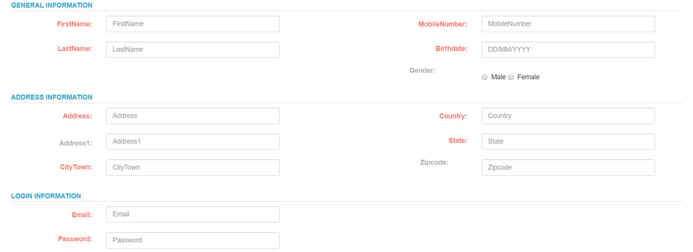

Figure 2: Prototype of Registration Form

1. **Login Page:**

* The Login page will contain two input fields as shown below to authenticate the already existing users.
* If the user does not have an account, he can simply click on the “**Register here**” option and he will be redirected to the registration page.

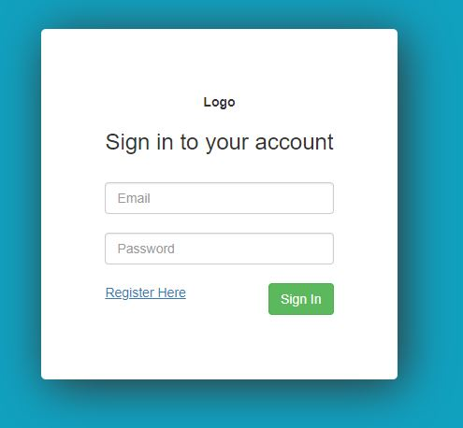

Figure 3: Prototype of Login Form

1. **Home page**:

* The home page will be displayed to the user as soon as he clicks on the URL of the website.
* The user can view the products on the site and will be able to view its price as well, he will only be able to contact the seller after he signs into the site, clicking on a product will redirect him to the login page.
* A **categories bar** will be displayed on the left of the home page so that the customer can navigate through different categories.
* Links to different social media accounts of the SS and its contact information will be displayed in the bottom of the page.
* A **navigation bar** which if signed in shows the users name else, shows the options to login/register, it will also contain options such as cart and the user’s recent orders, shopping cart and option to post a product.
* The **search bar** will be displayed on the required pages and after entering the text, when the user clicks on the search icon, the website will dispay the results.

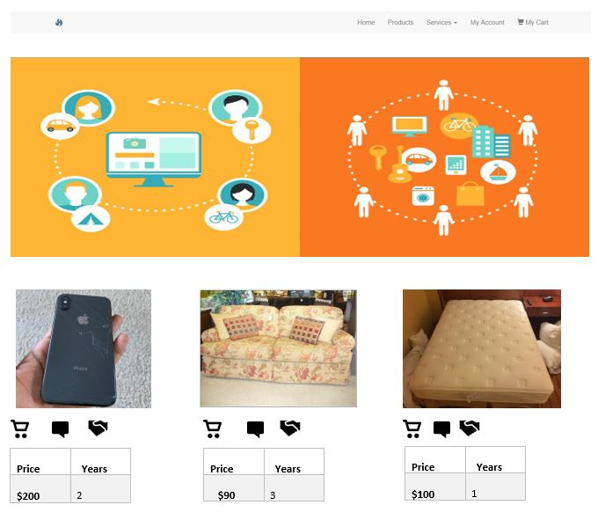

Figure 4: Prototype of home page

1. **Message box:**

* When a buyer wants to contact the seller, he can simply click on the message icon and he can communicate with the seller.
* The message box will pop up on a different page with a message box with a limit up to 500 characters.

1. **Cart page:**

* When the user clicks on the cart symbol of the navigation bar, a page that contains the list of items that the user added into the cart appears and each listed item will also have an option that says delete or buy.

1. **Product Posting page:**

* When the user wishes to sell a product, he will have to click on the sell option on the navigation bar and he will be redirected to a product posting page.
* This page will have an option “**browse**” and a few information input fields describing the product, once the user clicks the **submit** button the product will be posted on the webpage under the category that it belongs to.

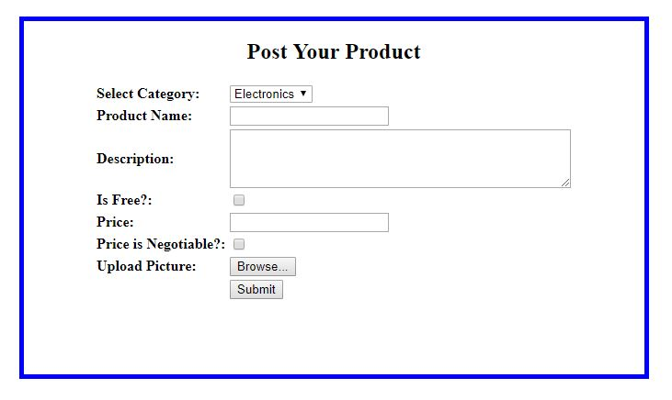

Figure 5: product posting form

**Screen Layout Constraints:**

* This website follows the regular screen layout of the modern web browsers such as Google Chrome, Safari and IE9.
* All the components on the website fit perfectly to the browsers screen dimensions, mobile view of the site may be difficult to view, since it is a web application.

**4.2 Hardware Interfaces:**

* RAM: 4GB or higher
* Internet: LAN.
* Supported Devices: Windows PC, Mac PC, Ubuntu and other Linux platforms.

**4.3 Software Interfaces:**

* Communication between the web server and database takes place through the servlet API’s that are coded in the application.
* Since, the project uses java spring framework, it makes use of spring libraries such as “commons-logging-1.2.jar”.
* The database MYSQL should be connected to the IDE using a “mysql-connector-java-5.1.46-bin.jar” file to initiate JDBC connections.
* The project is created as a maven project and hence a file named “pom.xml” will handle the dependencies in the project.

**4.4 Communication interfaces:**

* HTTP request and response calls are used for communication between the server and the application.
* The connection between the client and the server uses Connection oriented communication, TCP/IP—Transfer Control Protocol/Internet Protocol, implements reliable delivery of messages.

**5. Other Nonfunctional Requirements:**

**5.1 Performance Requirements:**

* **Title**: The site load time.

**Description**: The response time for the end user to receive the site’s homepage after entering the URL in the browser window.

**Must**: The site should take no longer that 8 seconds to load completely.

**Wish**: The site should take no longer that 5 seconds to load completely. [4]

* **Title**: The results from search and their images load time.

**Description**: The response time for the end user to receive the search results with completely loaded images

**Must**: The site should take no longer that 7 seconds to load completely.

**Wish**: The site should take no longer that 4 seconds to load completely. [4]

* **Title**: The login and registration confirmation

**Description**: The response time for the end user to enter the site after clicking the login or registration button.

**Must**: The site should take no longer that 2 seconds to login/register a user.

**Wish**: The site should take no longer that 2 seconds to login/register a user. [4]

* To efficiently achieve all the performance requirements mentioned above, the images uploaded by the user should be less than 1MB in size.

**5.2 Security Requirements:**

* Only designated administrators of the database will have access to the user information.
* Encryption of sensitive user data such as passwords, phone number and address before storing it into the database will be carried out.
* The details of the buyer/seller must be kept confidential until they come to an agreement or should be displayed to the other users only if they wish to.

**5.3 Software Quality Attributes:**

* **Availability**: The availability of the system to the user, for example the server must be efficiently be able to handle the requests from 30 users at a time. And the communication between the database and the server should also take less than 5 seconds to serve user's request.
* **Usability**: Making sure that the system is easy to handle and navigates with no delays. Since the system has several states, it should be able to switch between its states appropriately.
* **Functionality**: The functionalities of the components of the system should work appropriately to avoid any data loss and feature failures causing the users to wait for a longer period than expected.

**6. Phases of development:**

**Core Functionalities:**

* User Registration and login
* Profile maintenance and update
* Item Posting
* Item Searching
* Item Buying
* Shopping Cart
* Message Box

|  |  |  |  |  |
| --- | --- | --- | --- | --- |
| **Release Plan** | **Dependencies** | **Description** | **Motivation** | **Release** |
| 3.1 | - | User Registration and User Login | The users should be able to register themselves into the website and the user should be able to login. Hence, it will be a part of our first phase. | 1 |
| 3.2 | 3.1 | Profile Maintenance and update | The user will be able to change his password and modify his information, for he should be registered first and hence, it a part of our first phase. | 1 |
| 3.3 | 3.1 | Item Posting | Posting the product into the specified category. Categories will be required for this feature. Hence it will be a part of our second phase | 2 |
| 3.4 | 3.3 | Item Search | Search of the product customer needs based on category or text.  Products should be posted first. Hence, it will be a part of our second phase. | 2 |
| 3.5 | 3.1, 3.3, 3.4 | Item Buying | The selection of item and communication between buyer and the seller is managed by this feature. And hence it is in the second phase. | 2 |
| 3.6 | 3.3 | Shopping Cart | The user would be able to add items to the cart. Since its dependent on product posting, it will be a part of our third phase. | 3 |
| 3.7 | 3.1, 3.3 | User Messaging | Communicate with each other through messages, it will be a part of our third phase. | 3 |

*Table (1): Development plan in phases [4]*

**Phase 1:**

The phase 1 of the project will be focused on development of the features 3.1 and 3.2. In the first phase we plan on developing basic GUI and will be mostly focused on making sure the functionalities work appropriately.

**Criticalities**:

1. In this phase the most critical functionality will be the user identity management, where we will have to maintain the sessions with user unique identity and maintain their identity in every page.
2. The next most critical functionality in this phase will be to make sure that the user profile maintenance is done accurately and his edited details should be stored properly into the database.
3. The normalization of the database tables should be done in a way so that we can efficiently fetch the data.
4. The sensitive details of the user should be encrypted before storing them into the database using SHA256 encryption algorithm.

**Phase 2:**

The phase 2 of the project will be focused on development of the features 3.3, 3.4 and 3.5. In the second phase as per incremental approach we plan on building the features mentioned in phase 2 and subsequently will focus on improving the look/feel of the website.

**Criticalities**:

1. The most critical feature of this phase is to allow the user to post a product and to make sure that the product is on the home page of the website, as soon as he posts it.
2. The next most critical feature is to provide a keyword search over the product based on its category and the name over the database and fetching the products that match the search and displaying them on the home page and when the item is sold it should be removed from the homepage consequently.
3. The front end criticality in this phase is to be able to resize the images into a particular grid size so that it occupies as less space as possible on the home page.

**Phase 3:**

The phase 3 of the project will be focused on development of the features 3.6 and 3.7. By the end of this phase we plan on developing a full-fledged application that is ready to use by implementing the final features and testing them accordingly.

**Criticalities:**

1. The most critical functionality of this phase is the message box, were a user should be able to communicate with another unique user on the website and the timely delivery of the message to the other user.
2. The next most critical functionality is to make sure that the items are added to the specific user’s cart and he should be able to delete and add items into the cart effectively and once the item is sold it should be marked sold in the shopping cart.